Assignment - 1

|  |  |
| --- | --- |
| **Student Name/ID Number:** | Francis Roel L. Abarca |
| **Academic Year:** | 2022-2023 |
| **Module Name:** | Front End Web Development |
| **Project Title:** | Information Architecture, Wireframe and Story Board |
| **Submission Date:** | September 23, 2022 |
|  | |
| **Learner declaration** | |
| I certify that the work submitted for this assignment is my own and research sources are fully acknowledged.  Student signature: Date: | |

Information Architecture

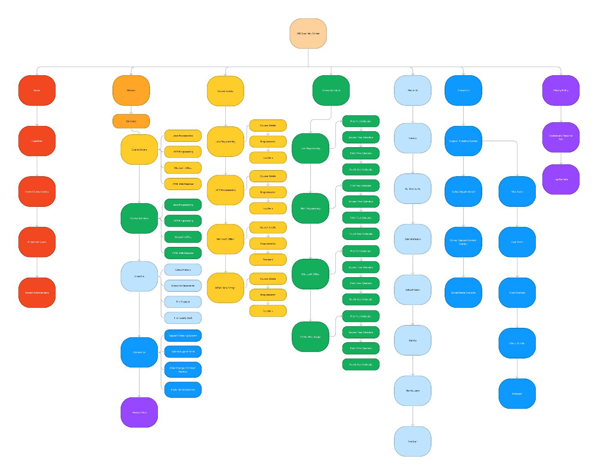

Wireframe Drawing

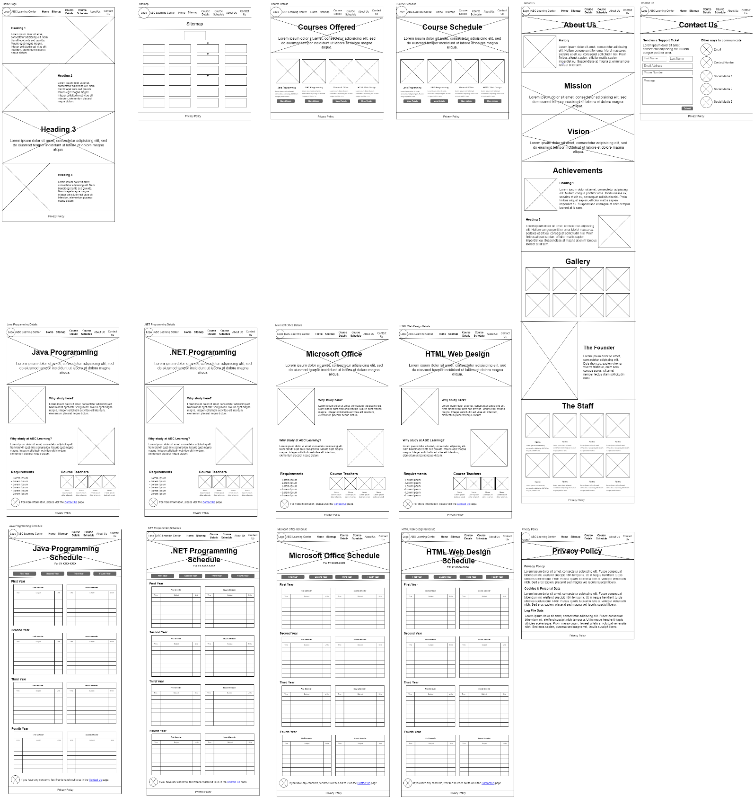

Storyboard